**Tutorial 18: Reusing Components**

In this tutorial, we will be demonstrating how to reus the modal component.

Make sure **Tutorial 17** is complete to be able to move on to this tutorial or clone the [vue3-firebase-course](https://github.com/younggrasshopperza/vue3-firebase-course) repository and go to branch called **Tutorial-17**.

**Step 1:** In the **App.vue** file, create a data property called **showModalTwo** with a value of false. Create function called **toggleModalTwo** that will change the value of **showModalTwo** to the opposite value when the function is called.

Look at the example below (**Line 28 and between line 35 to 37**):

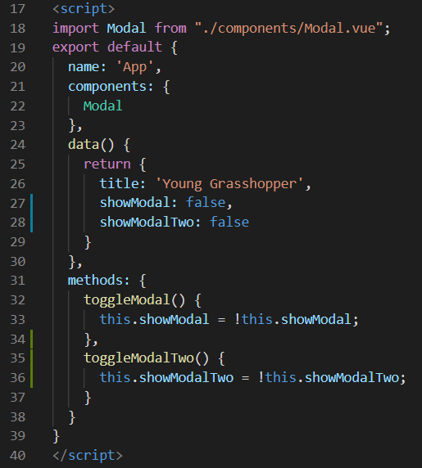

**Step 2:** In the **App.vue** file, duplicate the div with the Modal component inside directly underneath. Change the div tag to check whether showModalTwo is true. Remove the slot in the second Modal component. Change the close emit function called to toggleModalTwo. Create a button with a click event that calls the function toggleModalTwo.

Look at the example below (B**etween line 15 to 23**):

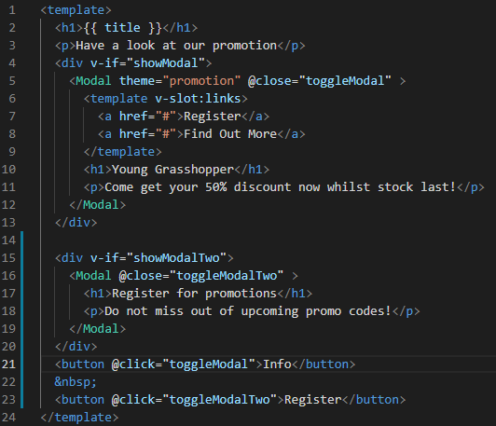

**Output:**

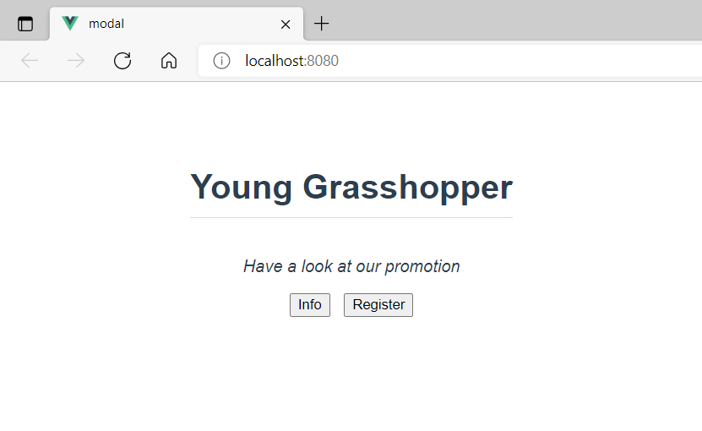

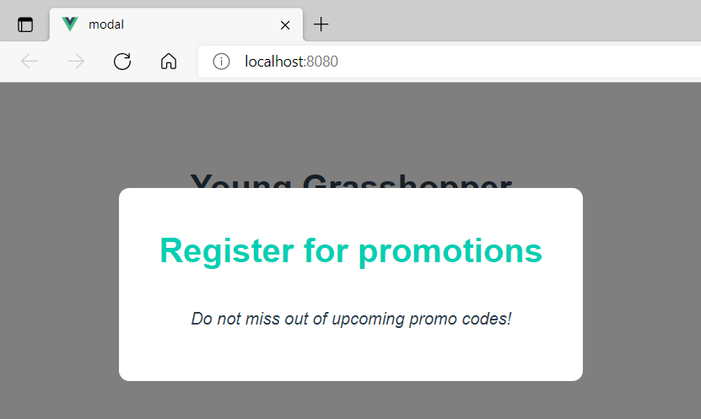

**You can view the code snippets from the** [**vue3-firebase-course**](https://github.com/younggrasshopperza/vue3-firebase-course) **repository under the Tutorial-18 branch**.